|  |  |  |  |  |  |
| --- | --- | --- | --- | --- | --- |
| Date | 8-Dec-22 | | | Tester Name | Richard Belanger |
| Environment | Penfax - Test | | | Login used | TEST2 |
| Operating System | Windows | Version: | Update: | | |
| Software Used | Edge | Version: | Update: | | |
| Not Applicable | Version: | Update: | | |
| Release version | 22.4.1 | | | | |
| Title | M45.08 Run Individual T4A information for slip | | | | |
| Test Type | Regression | | | | |
| Test Scenario | Create payment for a member and run the individual T4A tax slip | | | | |
|  |  | | | | |
| Expected Results | Payment and T4A tax slip will be in correct amounts | | | | |
| Pass/Fail | Pass | | | JIRA# | N/A |

Describe your steps with screenshots:

Member received a Lump Sum payment>SID = 133457

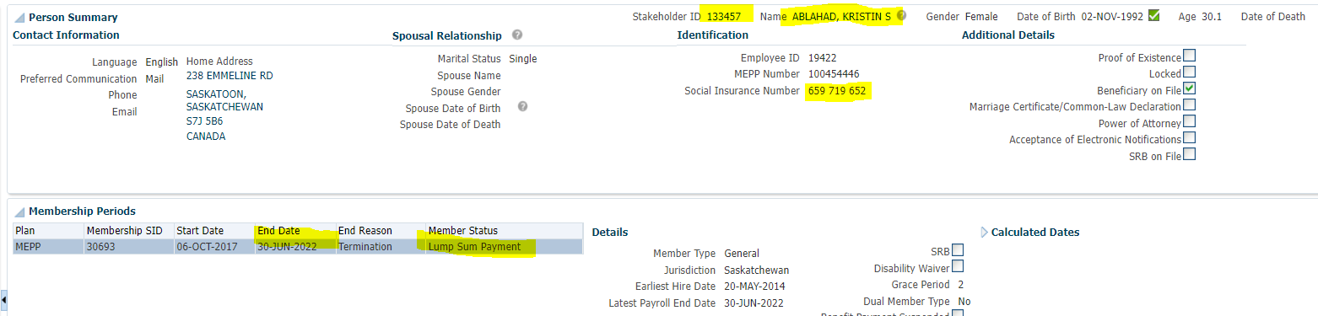

Payment History

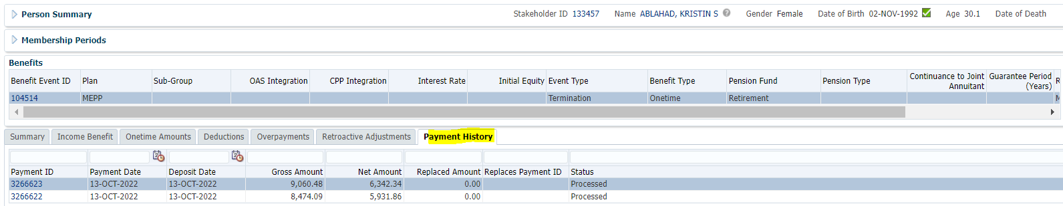

Create a Tax slip for Member

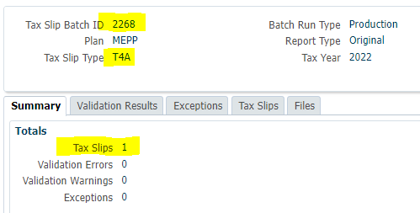

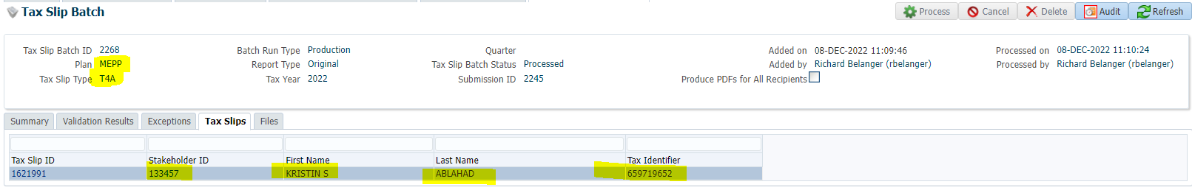

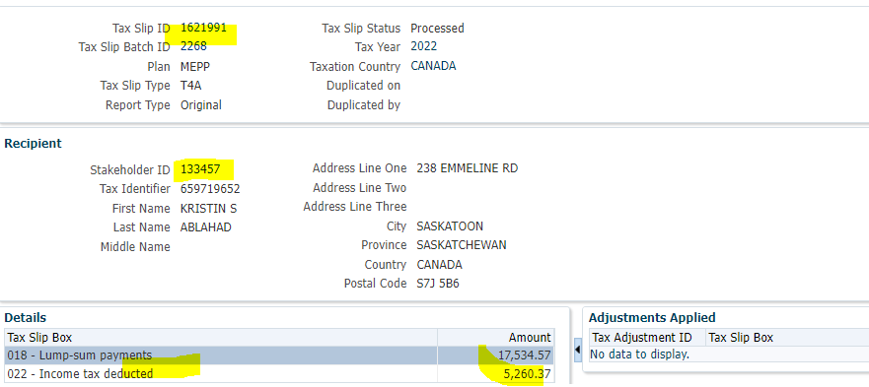

Communication>Tax Slip created>Click on Filename link

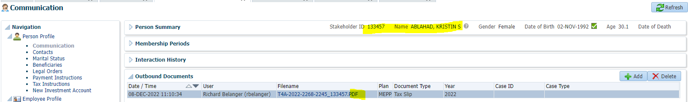

T4A Slip

